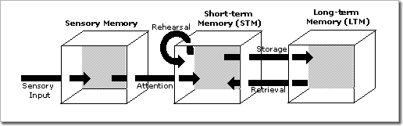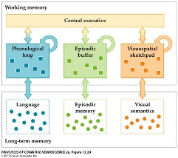Free Recall

**1: What is** **concreteness** **effect**:

-Dual-coding hypothesis (Paivio): Concrete words are encoded twice in memory: once in terms of their verbal attributes and once again in their imaginal attributes

-Context availability model: More associations tied to concrete words compared to abstract

**Serial position effects:**

Primacy effect: The first words encoded have been rehearsed longer and can therefore be recalled

Recency effect: The last words encoded are still available in STM and can therefore be recalled

**2: The article:** Ebbinghaus used nonsense words, observed primacy and recency effects

This experiment uses real words to also investigate the concreteness effect.

As can be seen in Atkinson-Shiffrin multi-store model and Baddeley’s model of WM, this experiment relies on rehearsal to be a part of the encoding or maintenance proces

**3: Hypothesis:** Expect to find **primacy**, **recency** and **concreteness** effects

- Expect to be able to **nullify** **recency** effect through **interference**

**4: Method**

* Read alternating concrete and abstract 20 words wordlists at 1 word per 2 seconds 🡪 P immediatly recalls 🡪 Wait 1 minute before reading the next list.

5: Results: Figure 1: **Primacy** and **recency** effect 🡪 Inverse bell shape. **Concreteness effect** 🡪 Concrete words follow a higher path. **No** **recency** **effect** for interference lists.

Repeated ANOVA: Confirm the findings with **main effects** of list type and word position. **Interaction** of list type and word position 🡪 interference list works

Repeated ANOVA w/o interference 🡪 **main effect** of list type 🡪 confirms concreteness effect.

Repeated ANOVA w/o word position 🡪(using only first 2 words) 🡪 **main effect** of list type 🡪 concreteness effect is not mitigated by primacy effect.

Table 1: Probability of recall: First 2 > middle 4 in all lists

Middle 4 < last 2 in Concrete and abstract but **NOT** in interference (middle 4 = last 2)

* Individual data support general findings

**6: Conclusions**

Experiment provides evidence for:

- **Concreteness** **effect**

- **Primacy** effects for all lists

- **No recency** effect for **interference** list.

**7: Criticism** Are we really looking at episodic memory?

* + Participants *might* need to remember when they learnt the list 1 compared to list 2 to distinguish them when recalling (episodic)
  + **Tulving**: participants can recall the episodic memory of an item appearing in the list (autonoetic) or just know that they are a pair (noetic)

- Wernicke’s area: Speech understanding

- Broca’s area: speech production

**8: Grand perspective**

**Friederici & Fiebach**: Left basal temporal areas involved in higher-level visual processing and mental imagery were more strongly activated during processing of concrete words, whereas a left inferior frontal region showed greater activity during abstract word processing

**Craik & Lockhart**: Four levels of semantic processing: Structural (look), phonemic (rhyme), categorical (fish?), semantic (fit sentence?).

**Brown-Peterson task:** Trigram of letters -> interference task (counting backwards in threes) 🡪 recall trigram

* + Proactive interference: performance ↓ following each trail, but when task is changed, performance ↑

Memory models: **Cowan** (LTM, WM, 3-4 attention), **Baddeleys**: Phonological loop (inner voice), visual sketchpad (inner eye), episodic buffer (Integrates phonological loop, visual sketchpad and LTM and make available for consciousness as one complex episode) 🡪 central executive, **Atkinson-shiffrin:** Information 🡪 Sensory register 🡪 attention 🡪 STM 🡪 Rehearsal (loop) 🡪 Encoding 🡪 LTM